Assignment on Python Programming

Solve the following Problems in Python:

1. Write a Python program to print a string from a given input string where all occurrences of its first char have been changed to '$', except the first char itself.

Input String: ‘energetic’

Output : ‘en$rg$tic’

1. Write a program that prints whether a given string is palindrome or not.

A string is said to be palindrome if the reverse of the string is the same as string. For example, “abba” is a palindrome, but “abbc” is not a palindrome.

1. Take a list of integers as input. Remove the duplicate integers from the list. Print the updated list.

Sample Input : [1,2,1,3,5,3,7]

Output: Number of unique items- [1,2,3,5,7]

1. Write a Python program to count the number of even and odd numbers from a list of numbers. Print the count. Then remove the even numbers from the list and print the updated list.
2. Write a python function that takes three sides of a triangle as arguments and returns the area of the triangle.
3. Write a Python function that takes a number as a parameter and check the number is prime or not.
4. Given a two list. Create a third list by picking an odd-index element from the first list and even index elements from second.

Example: listOne = [3, 6, 9, 12, 15, 18, 21]

listTwo = [4, 8, 12, 16, 20, 24, 28]

Expected Output:

Element at odd-index positions from list one:[6, 12, 18]

Element at even-index positions from list two: [4, 12, 20, 28]

Printing Final third list :[6, 12, 18, 4, 12, 20, 28]

Page 1 of 3

1. See the following Table. The table contains 6 Month’s sales data for different products of the company.

|  |  |  |  |  |  |
| --- | --- | --- | --- | --- | --- |
| Month no | Toothpaste | Facewash | Shampoo | Moisturizer | Soap |
| 1 | 2500 | 1500 | 5200 | 9200 | 1200 |
| 2 | 2630 | 1200 | 5100 | 6100 | 2100 |
| 3 | 2140 | 1340 | 4550 | 9550 | 3550 |
| 4 | 3400 | 1130 | 5870 | 8870 | 1870 |
| 5 | 3600 | 1740 | 4560 | 7760 | 1560 |
| 6 | 2760 | 1555 | 4890 | 7490 | 1890 |

i) Read all product sales data and show it using a multiline plot. Display the number of sales per month for each product using multiline plots. (i.e., Separate Plotline for each product ). The graph will look like this: ( check this with the value given at the table; you will understand)

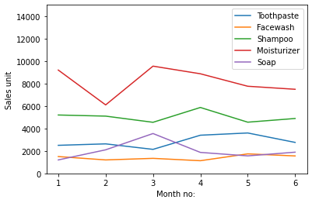

ii) Read Moisturizer sales data for each month and show it using a scatter plot. The plot will look like this:

Page 2 of 3

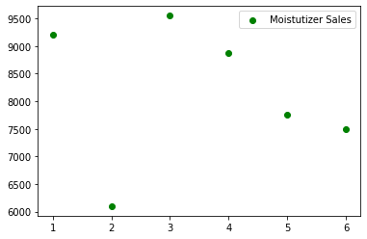

iii) Calculate the total number of sales each month and show the value using a bar diagram.